**Lunch Order Project**

1. Crated two customer named **Jane** and **John**
2. Deposited $50 and $100 to their account respectively.
3. John ordered a Pizza and Coffee that costs $30.
4. After successful order placement, funds transferred from John’s account to Jane’s account.
5. Updated balance printed.

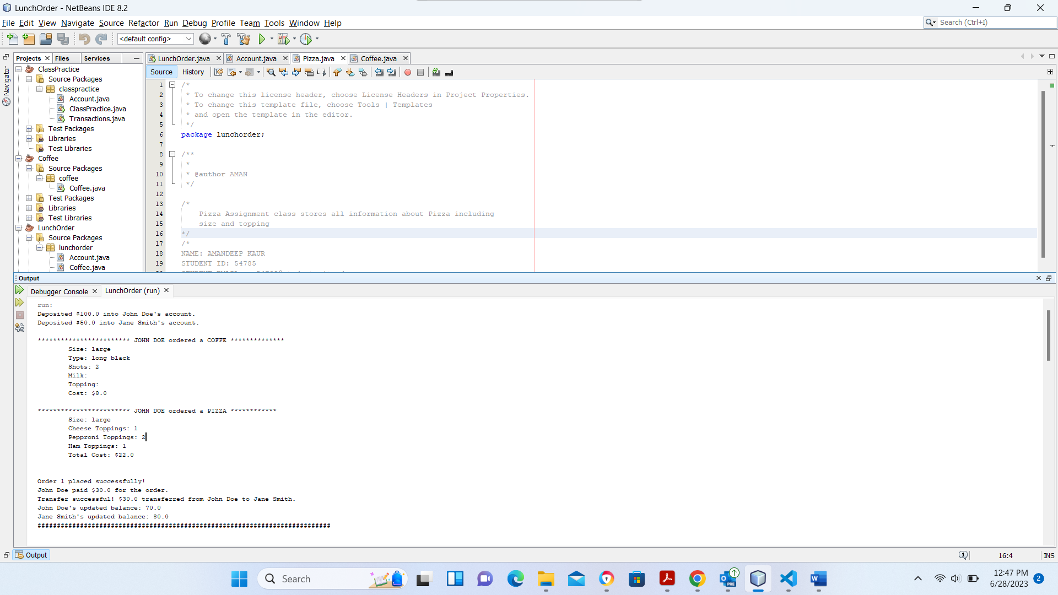

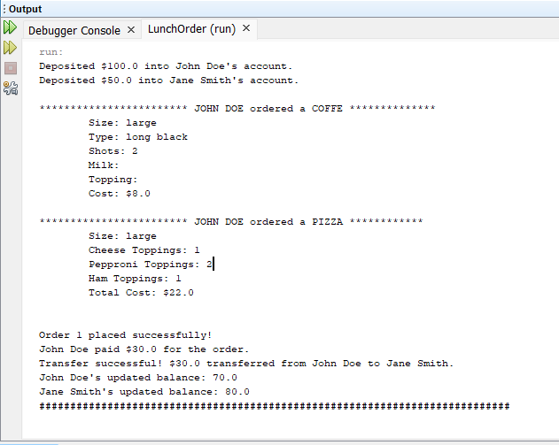

1. Same process followed by other 6 orders.

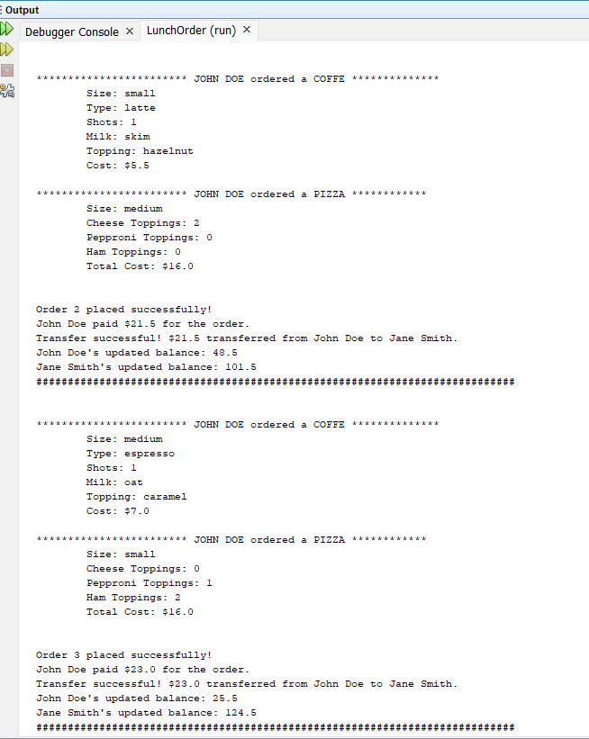

1. For certain order, there was no sufficient funds, hence order failed.

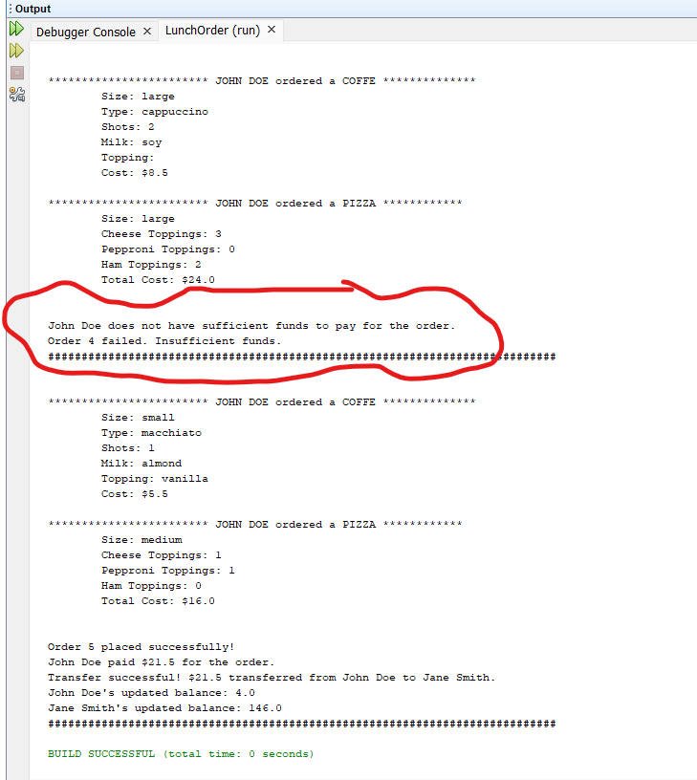

1. For the following order, as it costs less, there was sufficient funds, so order placed successfully.